Capstone Project

Review-2 Report

**Team details:**

Rohith Reddy Dirisala (19BCE7303)

Hruthik Yadav Madati (19BCN7092)

**Online Auction system**

**Results:**

**Web-page Layouts:**

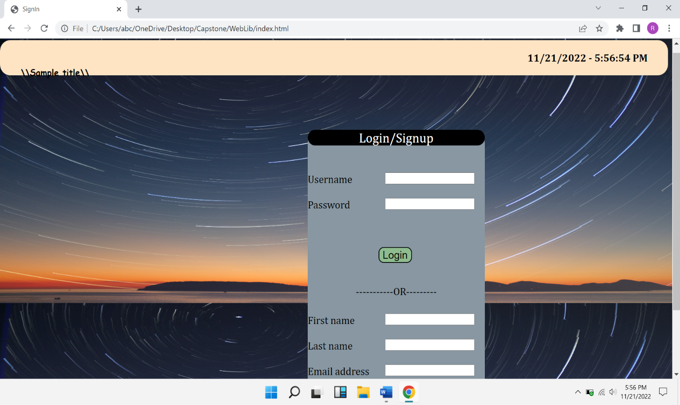

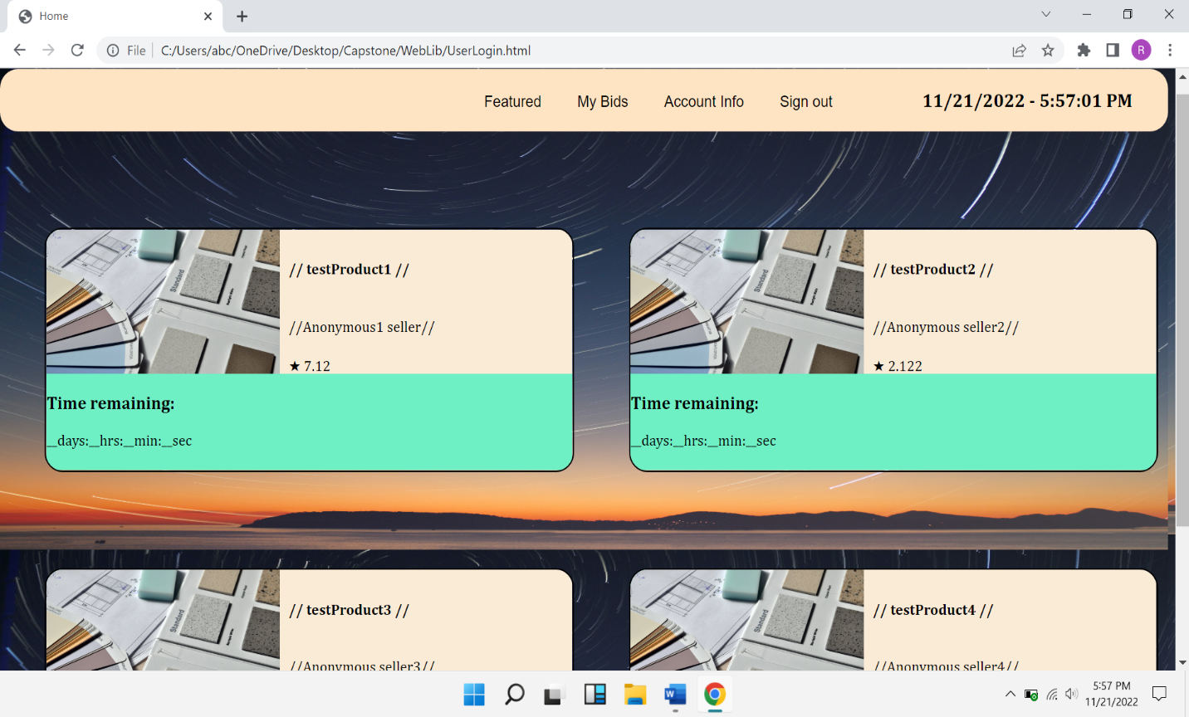

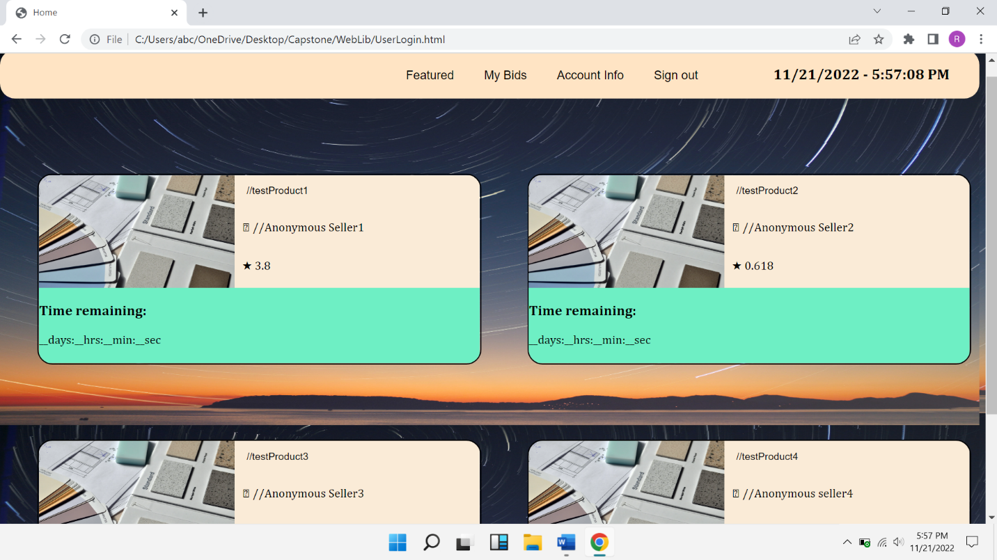

**Project Phases Progress:**

**Finished phases:**

1. Information gathering
2. Planning
3. Web design (Front-end development)

**Ongoing Phase:**

1. Back-end development

**Upcoming Phases:**

1. Content creation
2. Testing
3. Deployment

**Project Timeline:**

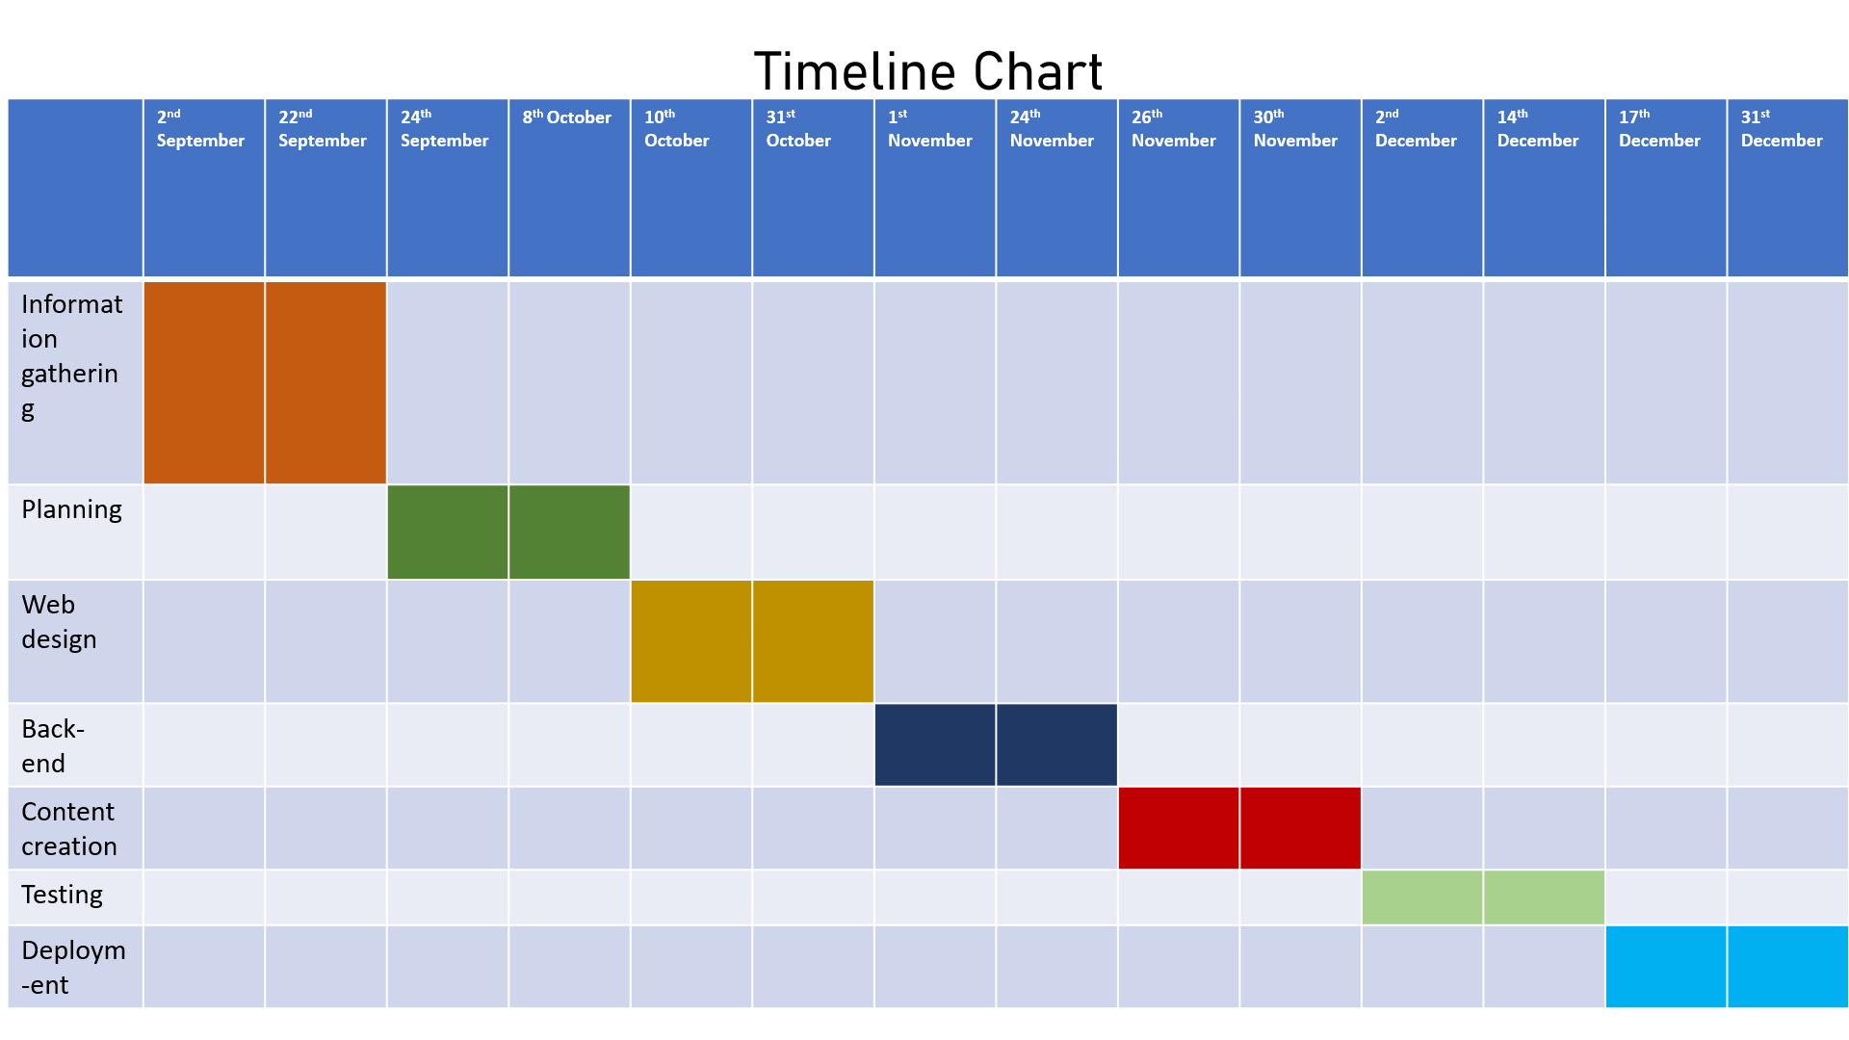

**Softwares/Tools to be used:**

**Front-end development:**

* HTML5
* CSS3
* JavaScript
* Visual studio code

**Back-end:**

* MySQL
* Java
* Php
* Eclipse IDE

**Testing:**

* Webload
* Burp Suite

**Web-Hosting:**

* Amazon Ec2 instances

**Collaboration:**

* GitHub
* Microsoft teams

**Previous Documentation:**



***Use-case diagram:***

**System**

Admin

Seller

Customer